Q1

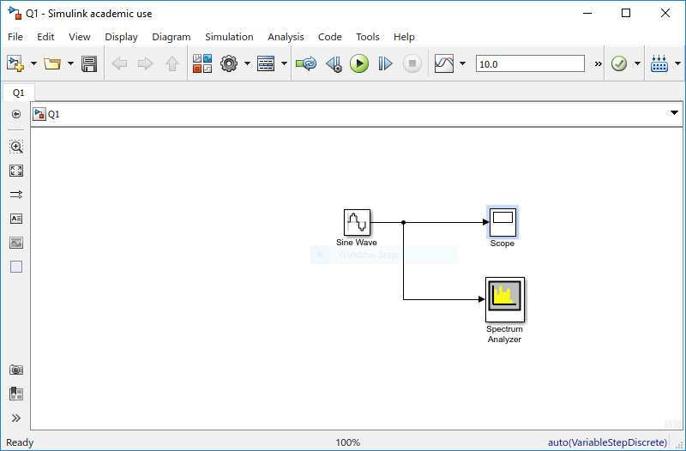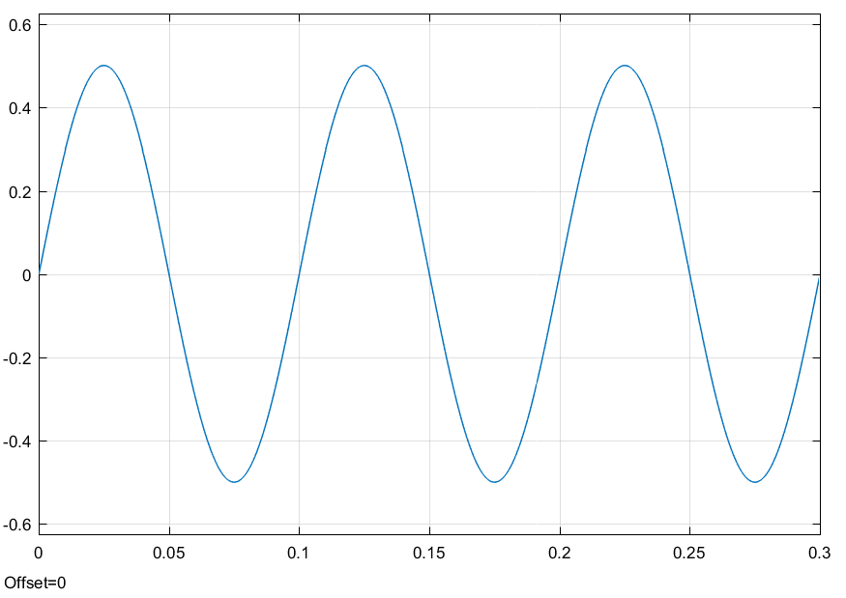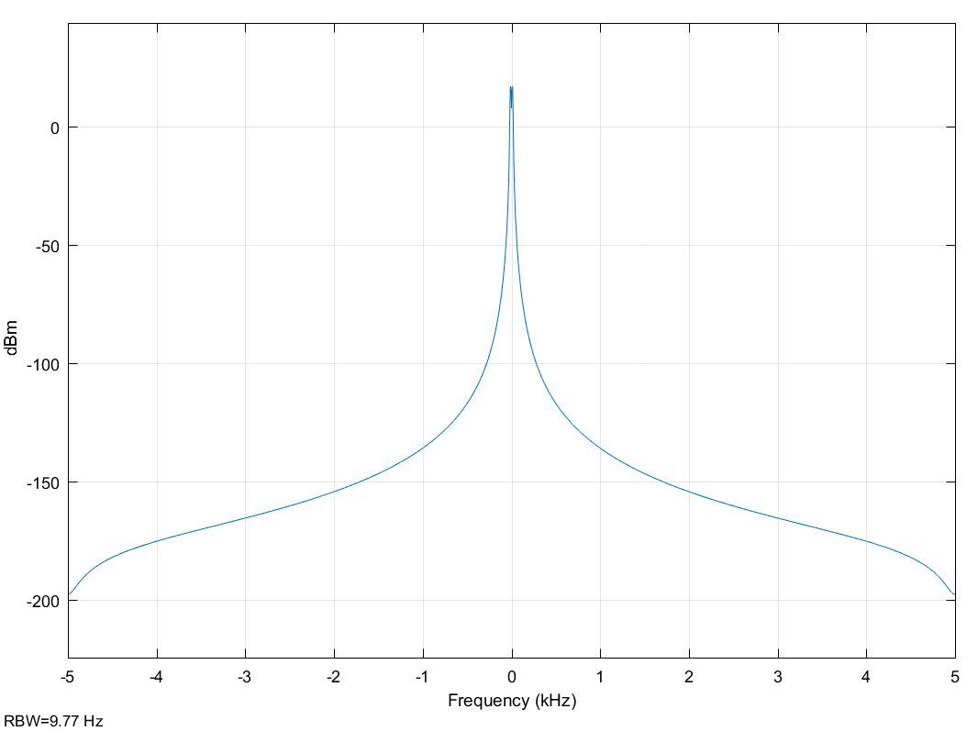

Amplitude = 0.5

Period = 0.1 s

Frequency = 10 Hz

Q2

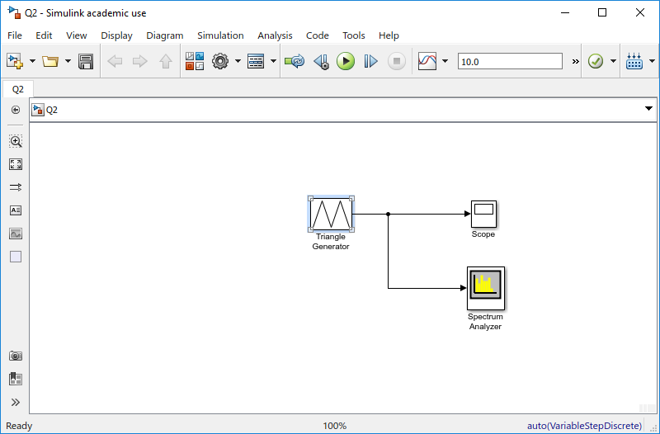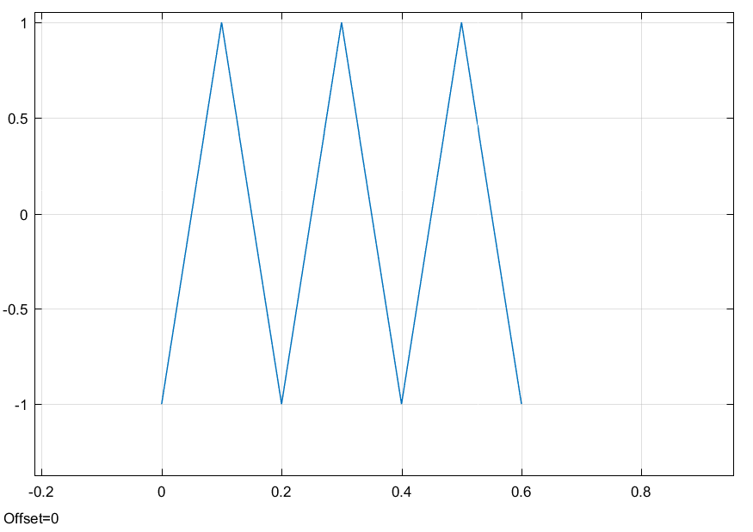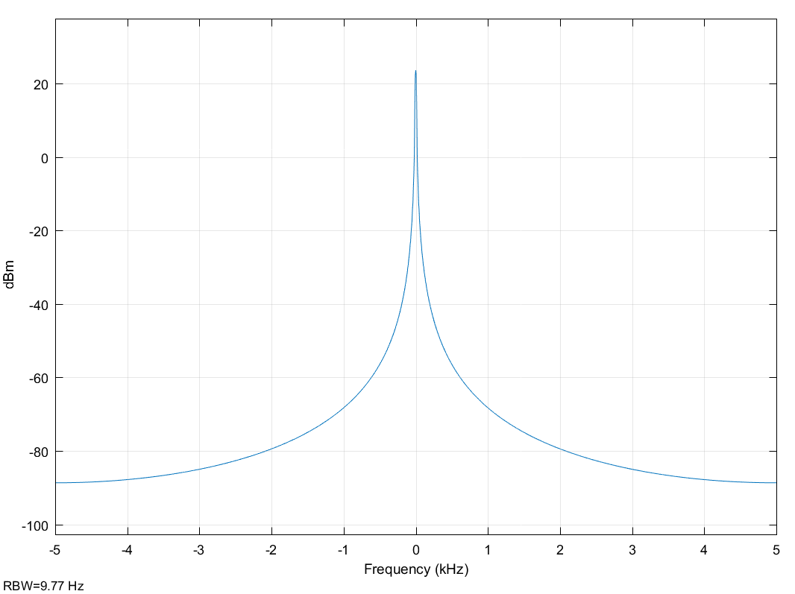

Amplitude = 1

Period = 0.2 s

Frequency = 5 Hz

Q3

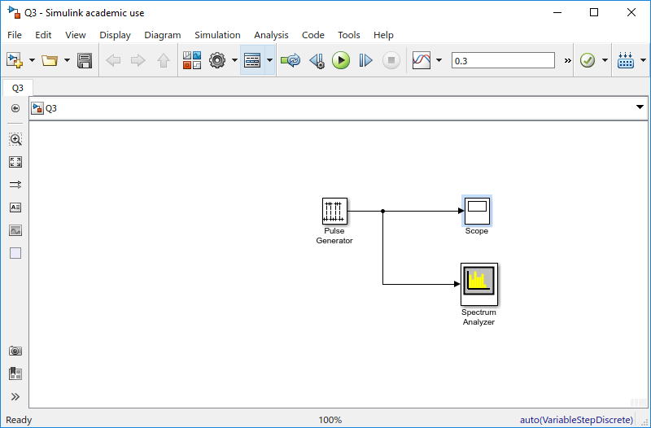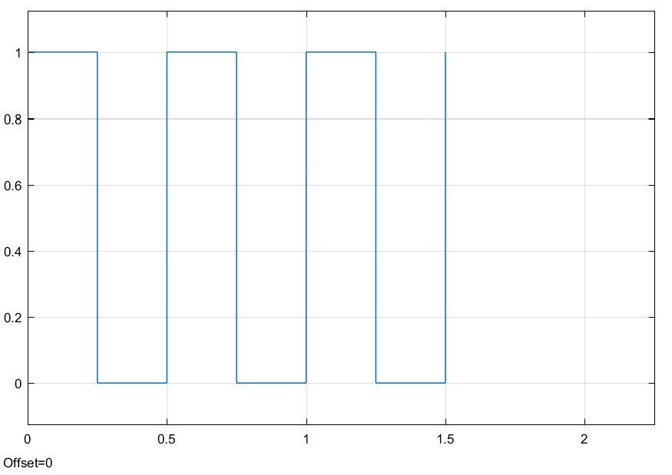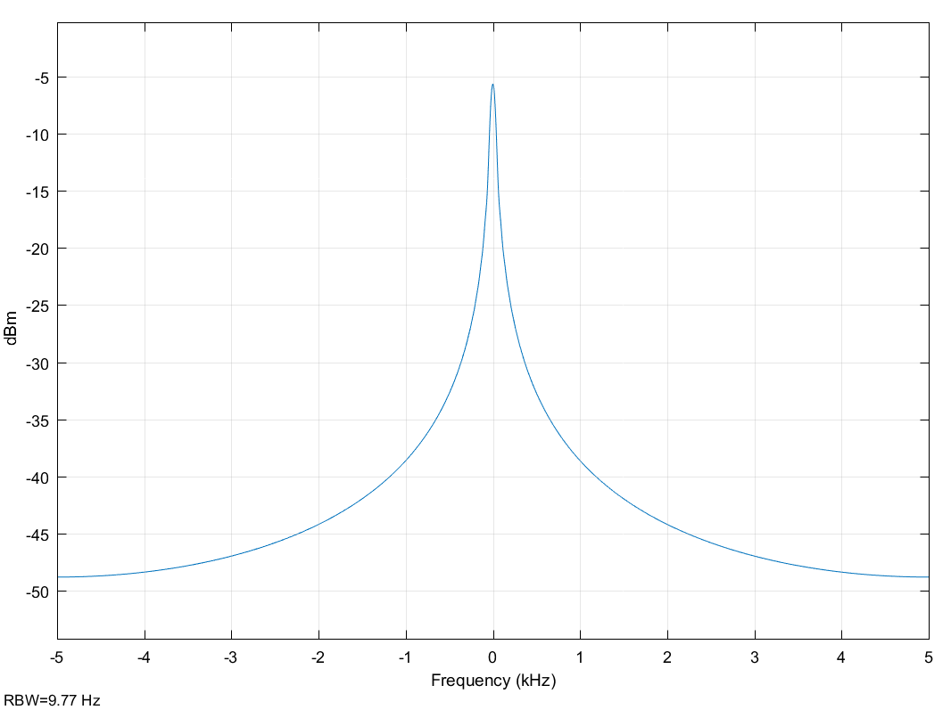

Amplitude = 1, based on pulse height

Period = 0.5 s

Frequency = 2 Hz

Q4

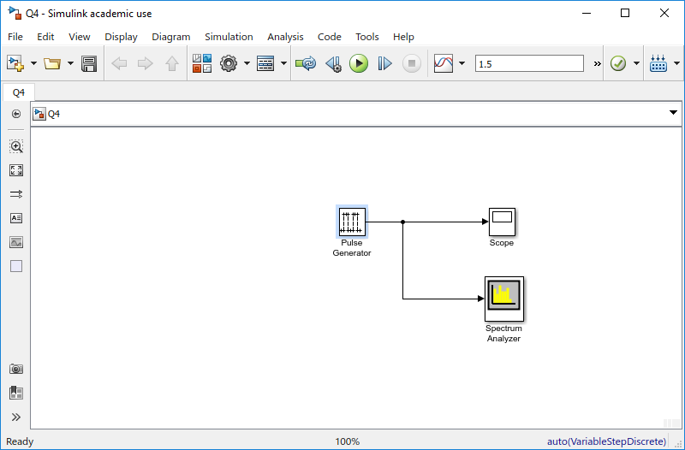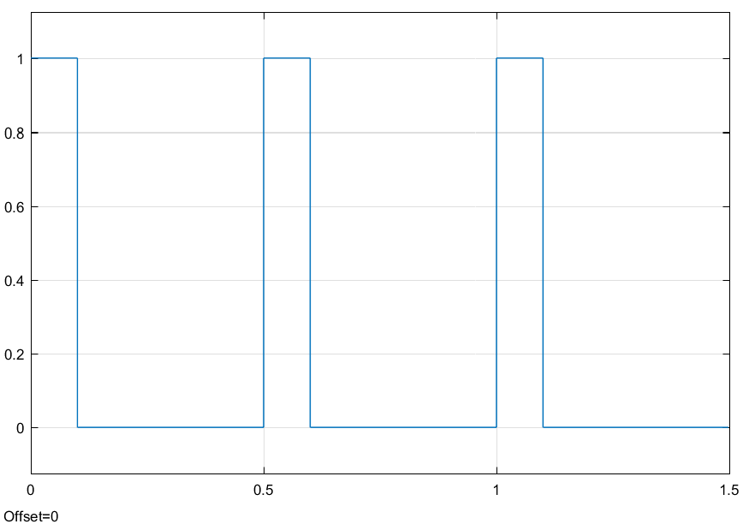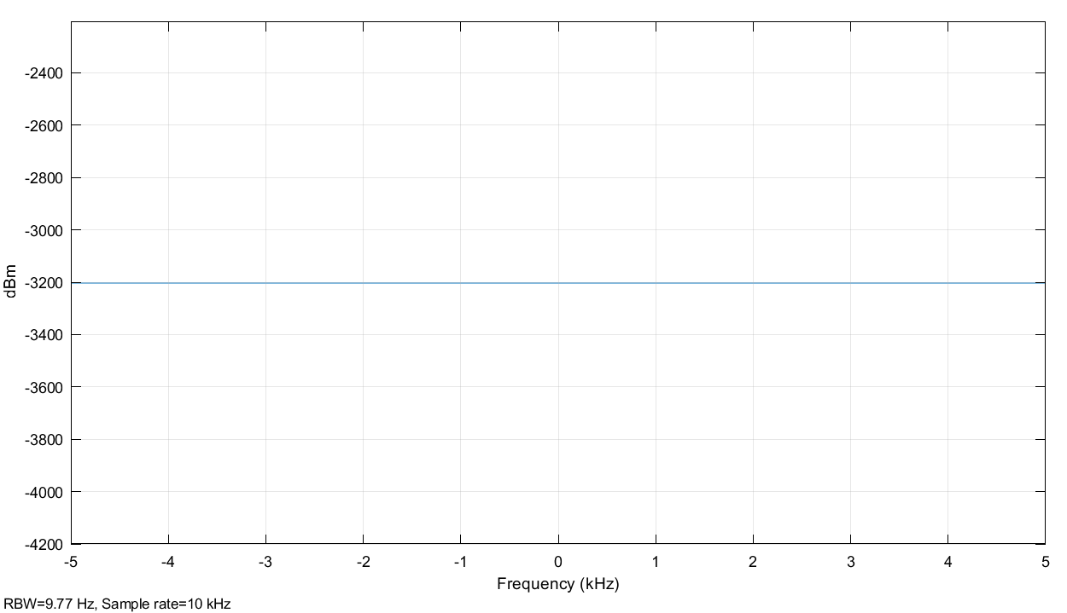

Amplitude = 1, based on pulse height

Period = 0.5 s

Frequency = 2 Hz

Q5

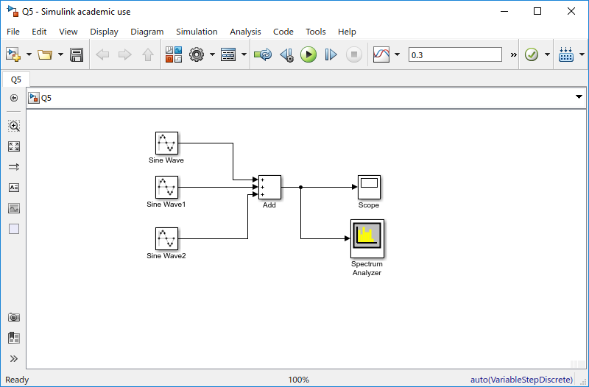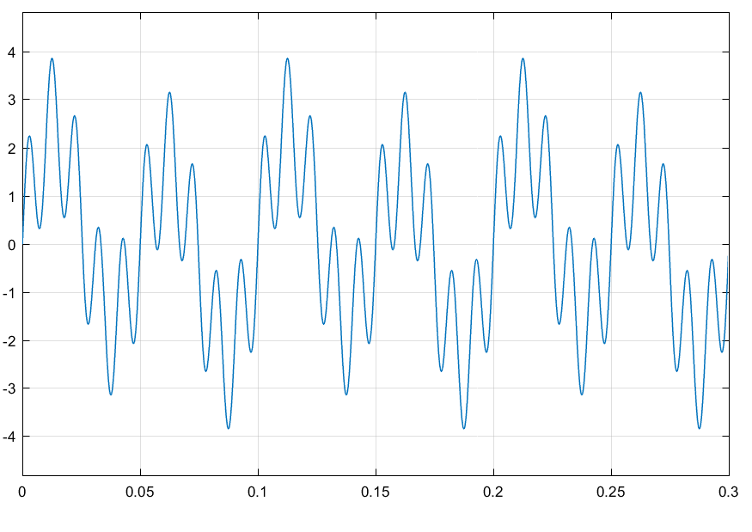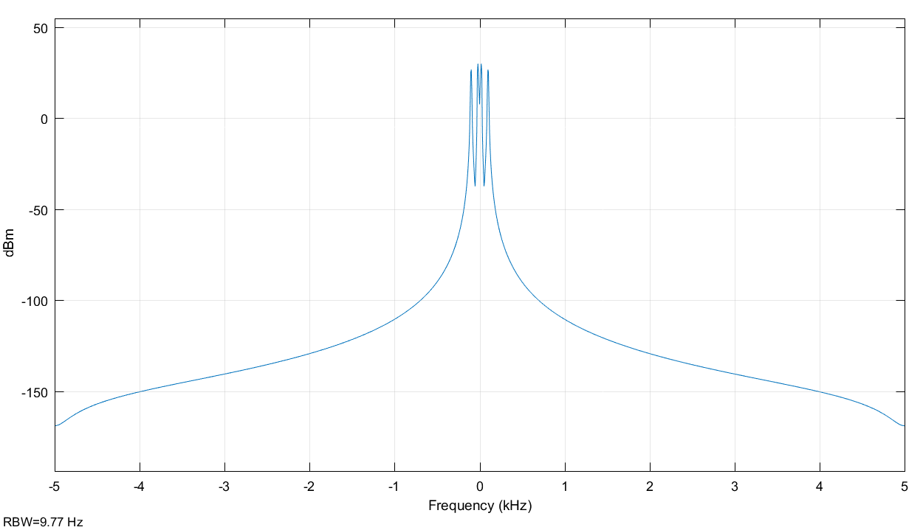

Amplitude = 3.85

Period = 0.1 s

Frequency = 10 Hz

Q6

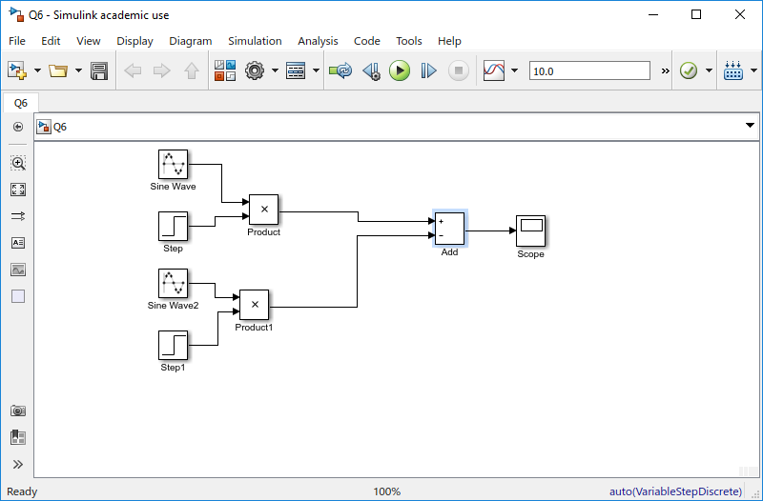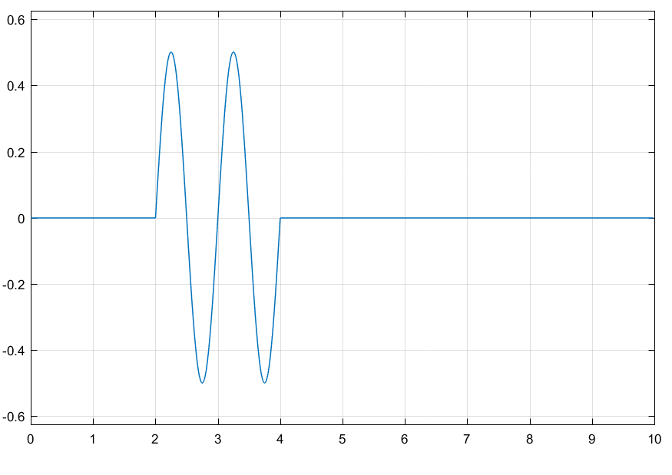

Comments on Periodicity:

Q7

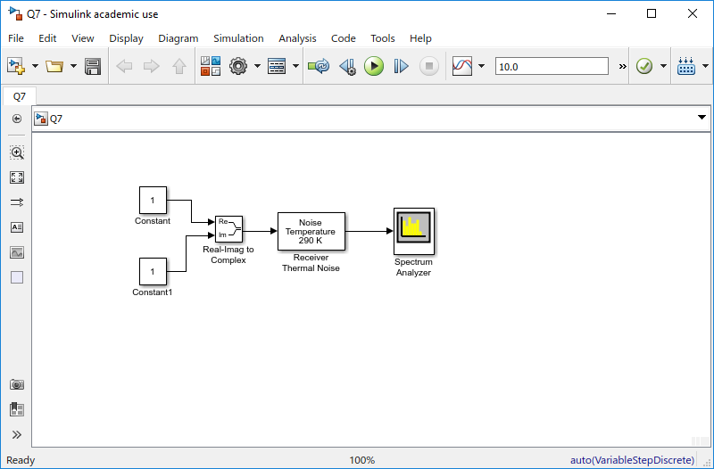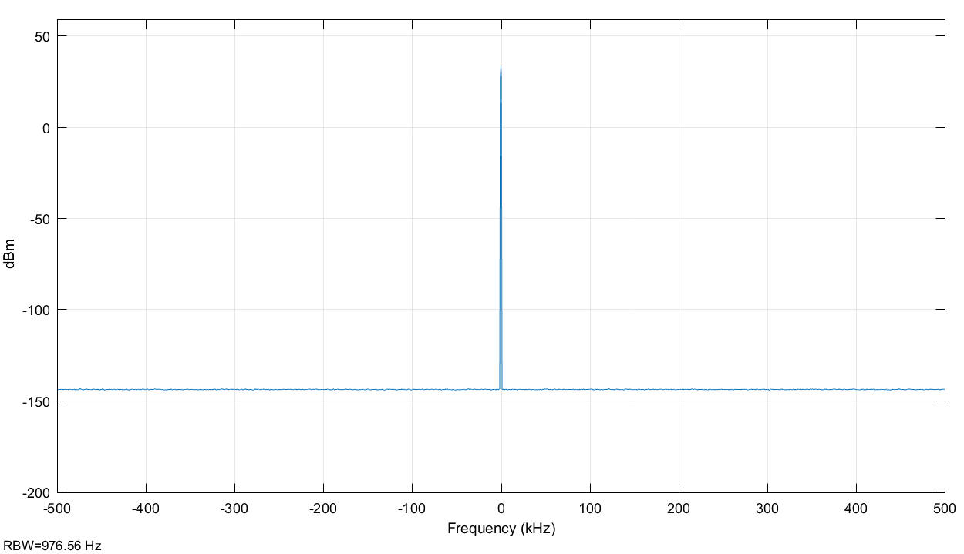

Bandwidth – Because it is a pulse, there is no bandwidth

8-9

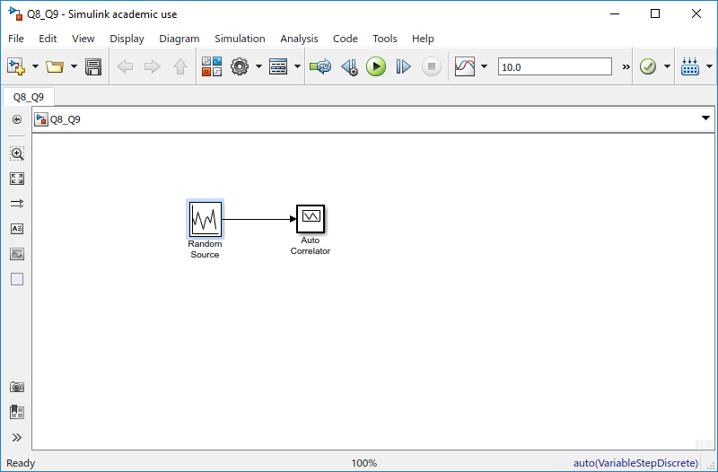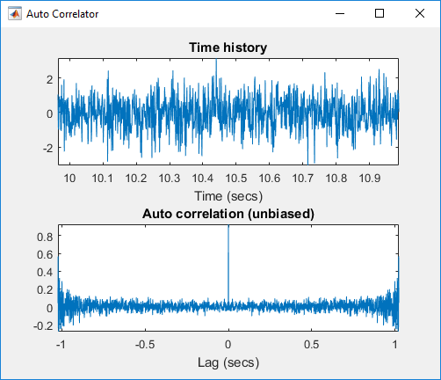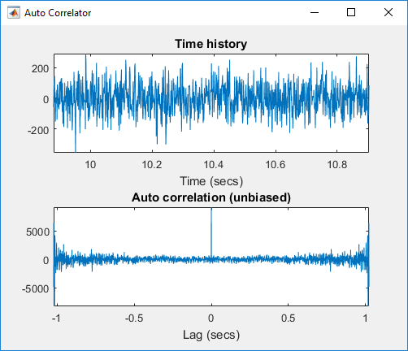

The height of the Auto correlation equal to the value of the variance. For a small variance, the values of the random signal are less spread out, than that of a larger variance.

Part 2

1. Sine Wave

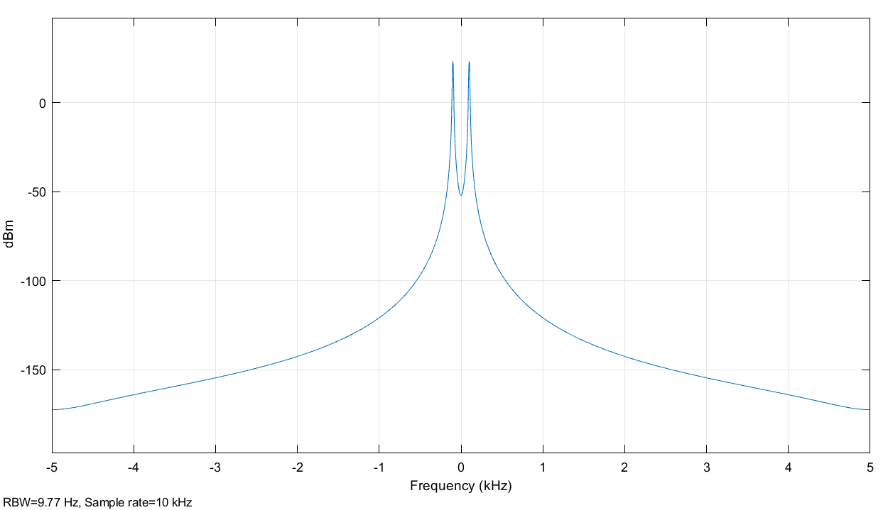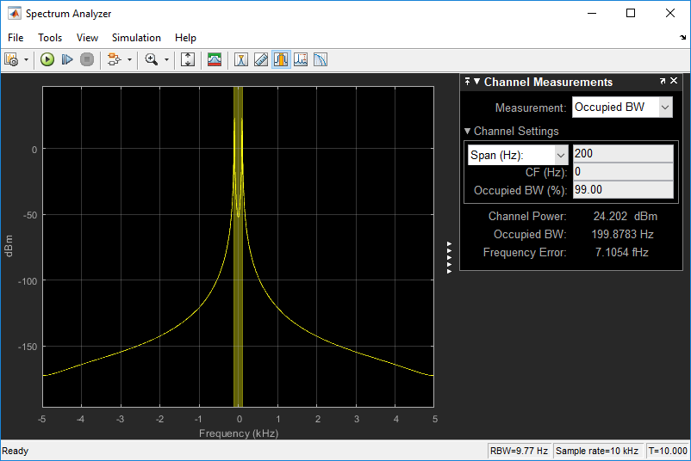

Source: Sine Wave

Bandwidth = 200 Hz

Frequency = 100 Hz

Channel Power = 24.202 dBm

1. Triangular Wave

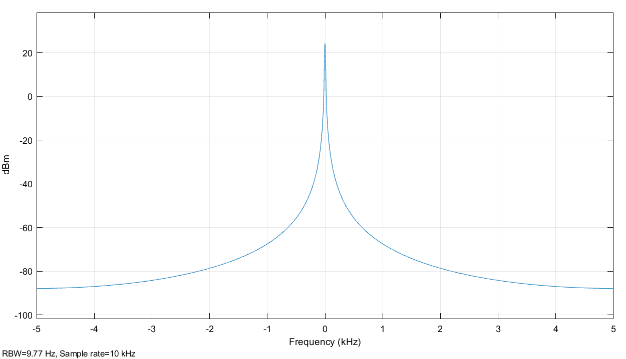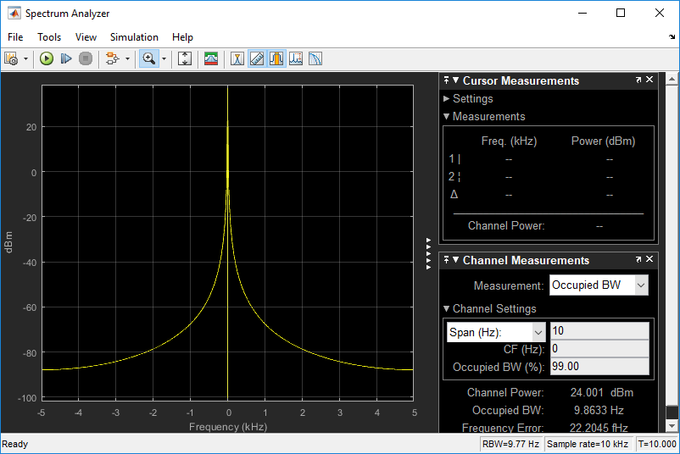

Sine wave: source

Bandwidth = 10 Hz

Frequency = 5 Hz

Channel Power = 24.001 dBm

1. Pulse

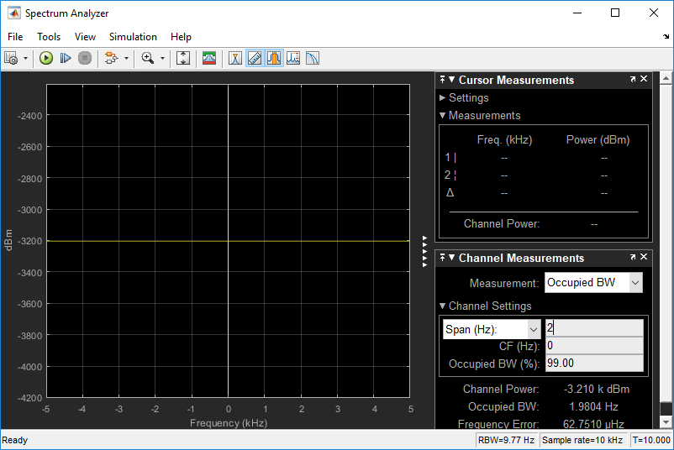

Source: Pulse Wave 50%

Bandwidth = 10 Hz

Frequency = 5 Hz

Channel Power = -3.210 k dBm

1. Pulse

